|  |  |  |  |
| --- | --- | --- | --- |
| Project Title : Tailored Application Access for Enhanced User Experience.  Team Members:  Goutham-<gouthamgopi10092004@gmail.com>  Reuel Jehoada-<reueljehoada2002@gmail.com>  Nandish- <nandishtn24@gmail.com>  Yuvan Shankar- <ys420173@gmail.com> |  | |  |
|  |  |  | |

**Project description:**

To design and implement a tailored access control system within Global Tech Solutions' ServiceNow instance that provides employees with role-specific applications and modules, thereby reducing confusion and improving operational efficiency.

**IMPLEMENTATION:**

**Activity-1**

1. Open service now developer Instance.
2. Click on All.
3. Search for Tables.
4. Under System Definition select Tables.

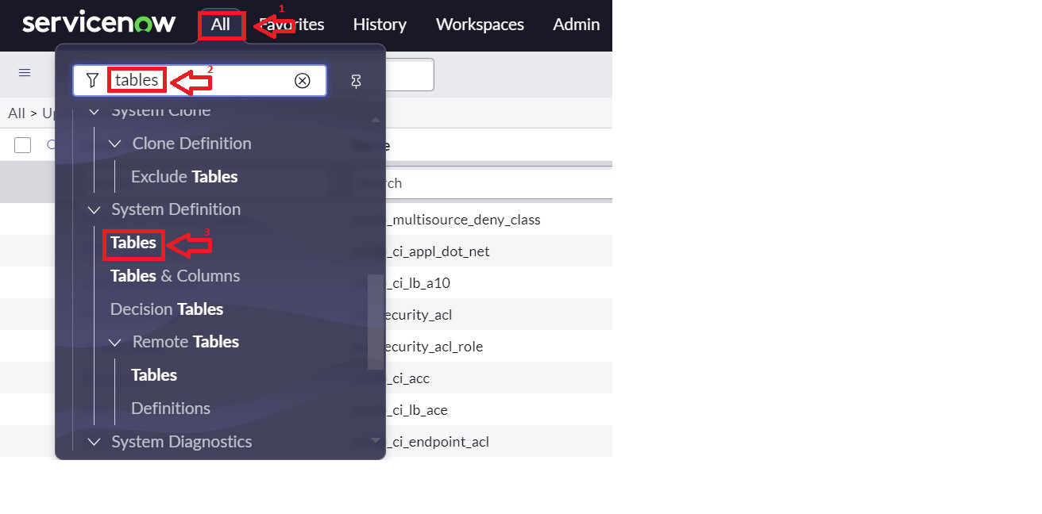

1. Then click on New.
2. Fill the Details as:

Label : Service Request

Name : Auto-Populated

Add module to menu : Select Create New

Leave everything as Default.

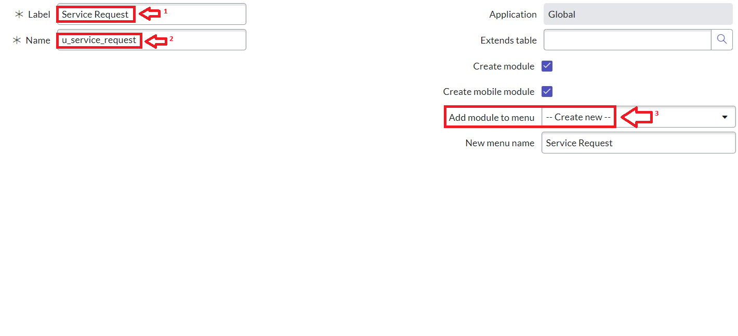

1. Under Columns : click on insert a new row.

Column label : Name >> Type : String

Column label : Issue >> Type : String

1. Click on Submit.

**Activity - 2: Create Users**

1. Open service now.
2. Click on All  >> search for users
3. Select Users under system security
4. Click on new
5. Fill the following details to create a new user

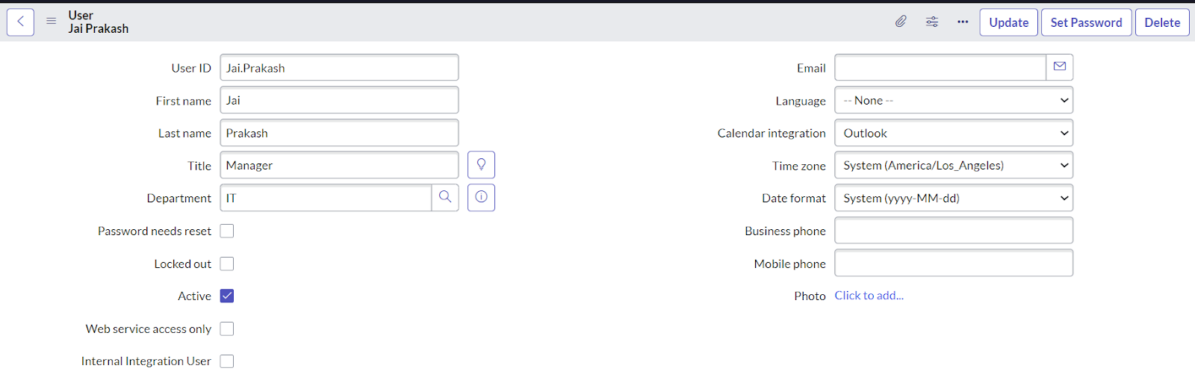

**Activity - 3: Create Groups**

1. Open service now.
2. Click on All  >> search for groups
3. Select groups under system security
4. Click on new
5. Fill the following details to create a new group.

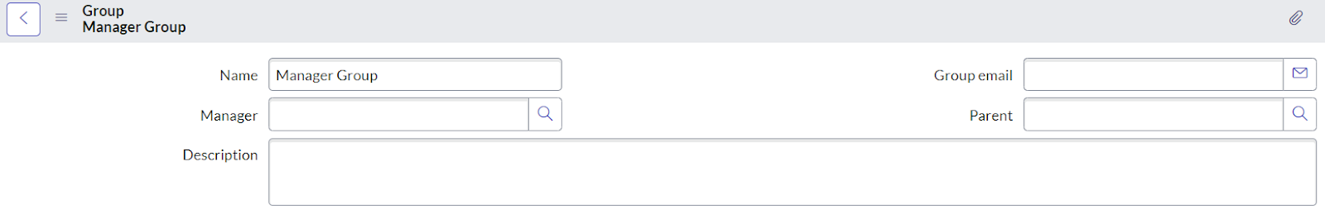

1. Under Group Members, click on edit.
2. Add the user(Jai Prakash) to the Manager Group and click on Save.
3. It would like below.

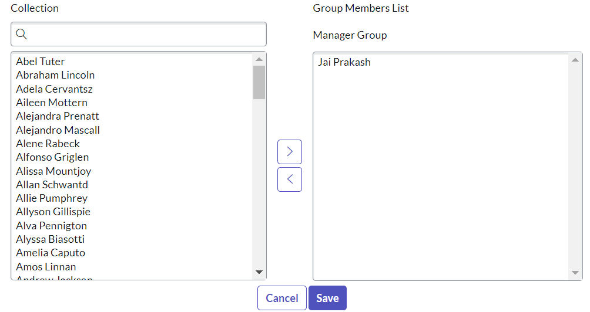

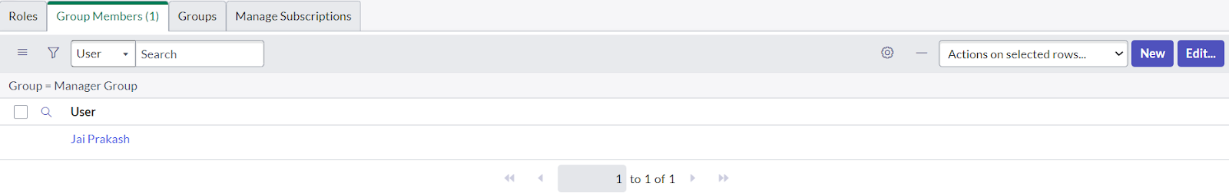

1. Click on save.

**Activity - 4: Create Roles**

1. Open service now.
2. Click on All  >> search for roles
3. Select roles under system security
4. Click on new
5. Fill the following details to create a new role

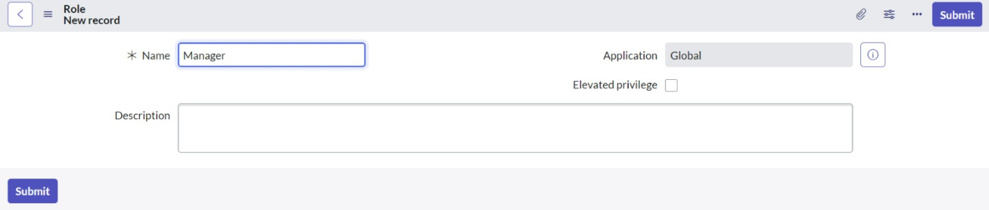

1. Click on Submit.
2. Click on All >> users
3. Search for “ jai prakash ”
4. Open the record, Go to the related list Click on roles
5. Click on Edit
6. Add manager to the selected list and Click in Save.

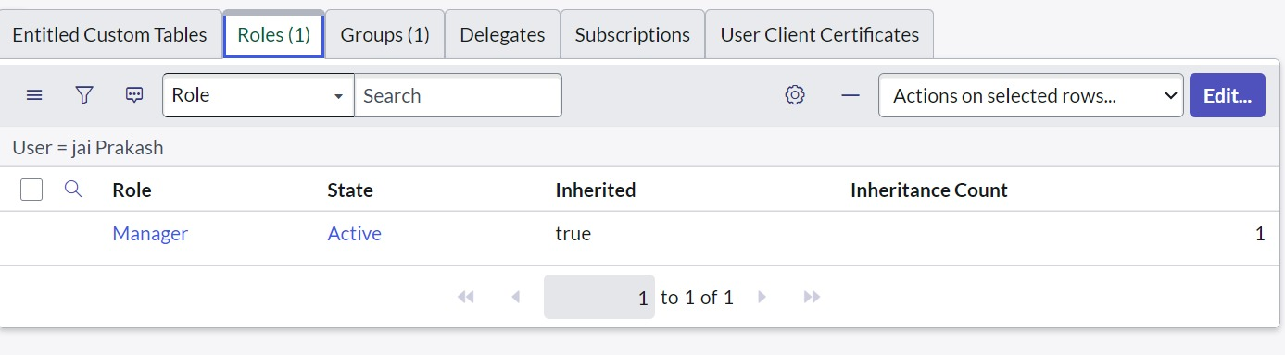

**Activity - 5: Creation of Modules**

1. Click on All.
2. Search for Application Menus.
3. Open Application Menus.

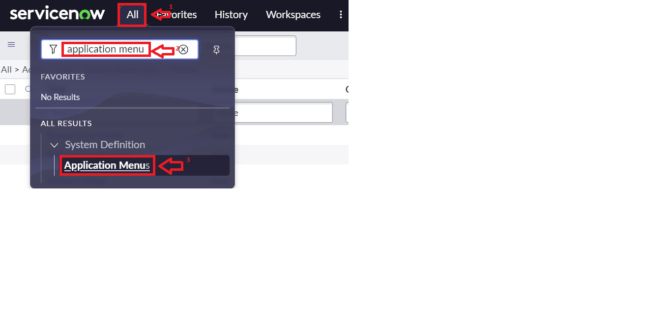

1. Under Title search for Service Request and open service request.

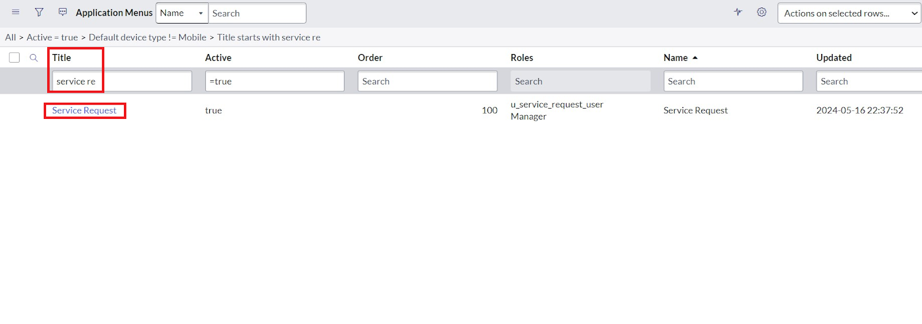

11.Under Roles, click on roles and Select the Role to which this should be viewed.

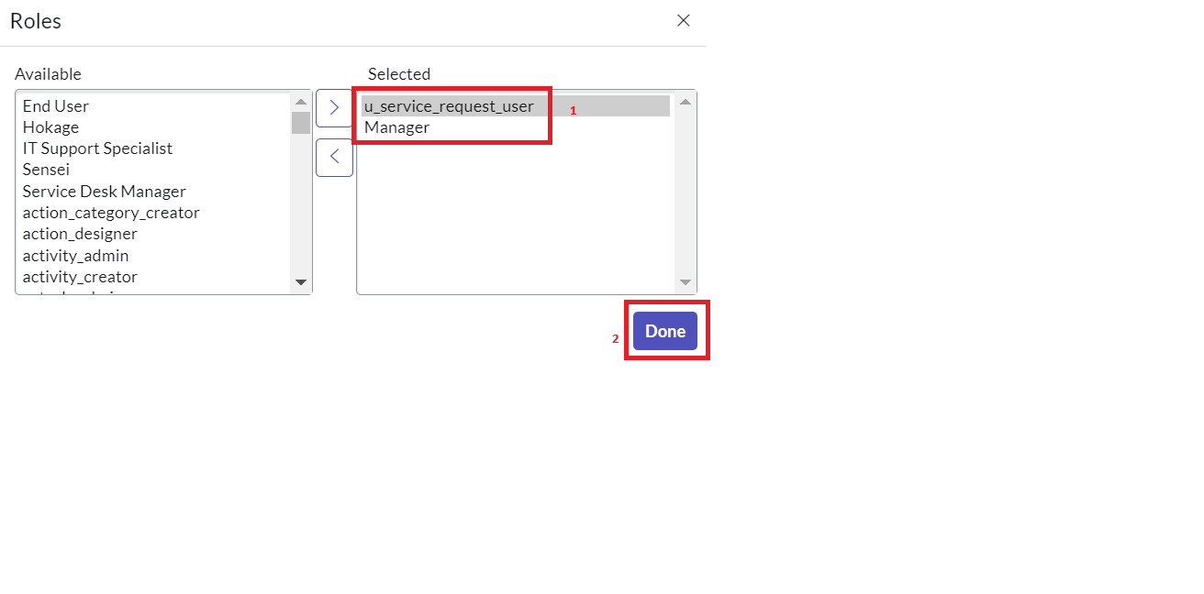

1. Click on Done.
2. Now under Modules. Click on New.

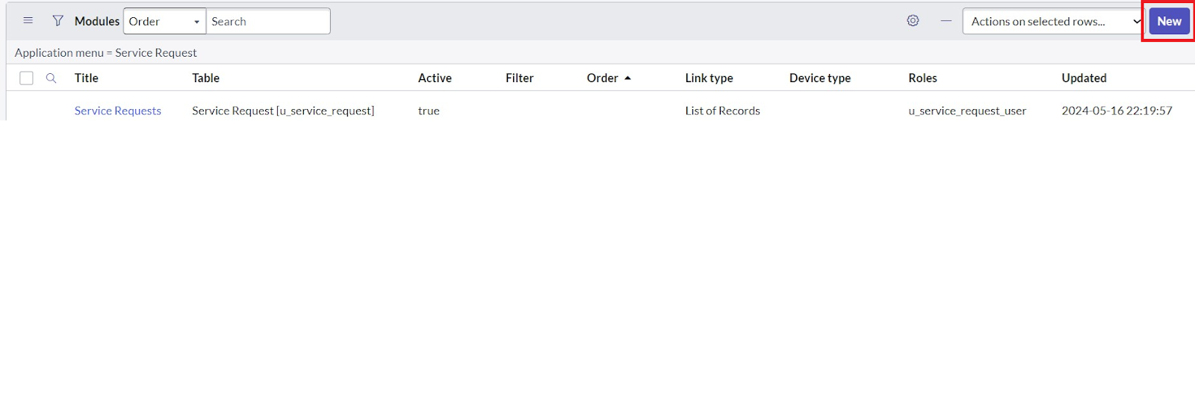

1. Enter the details as:

Title : Create New

1. Under Visibility >> Select roles and select the role you want to assign.

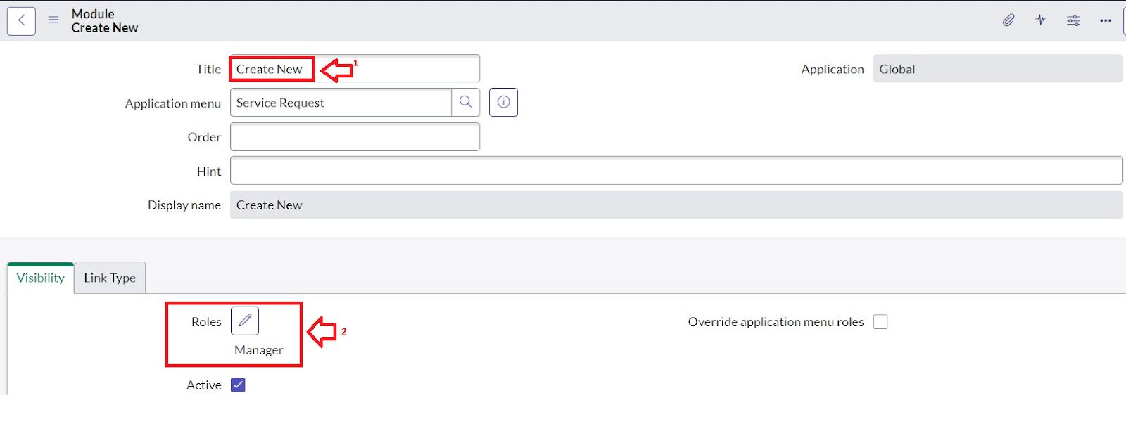

1. In Link Type, fill details as shown in figure.

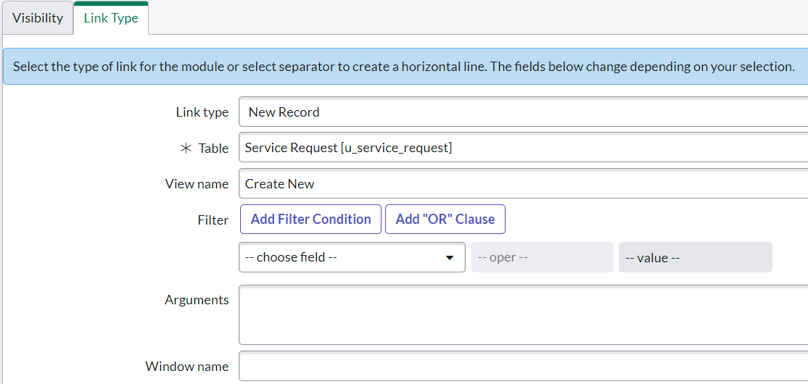

1. Click on Save.
2. Now under Modules. Click on New.



1. Enter the details as:

Title : All

1. Under Visibility >> Select roles and select the role you want to assign.

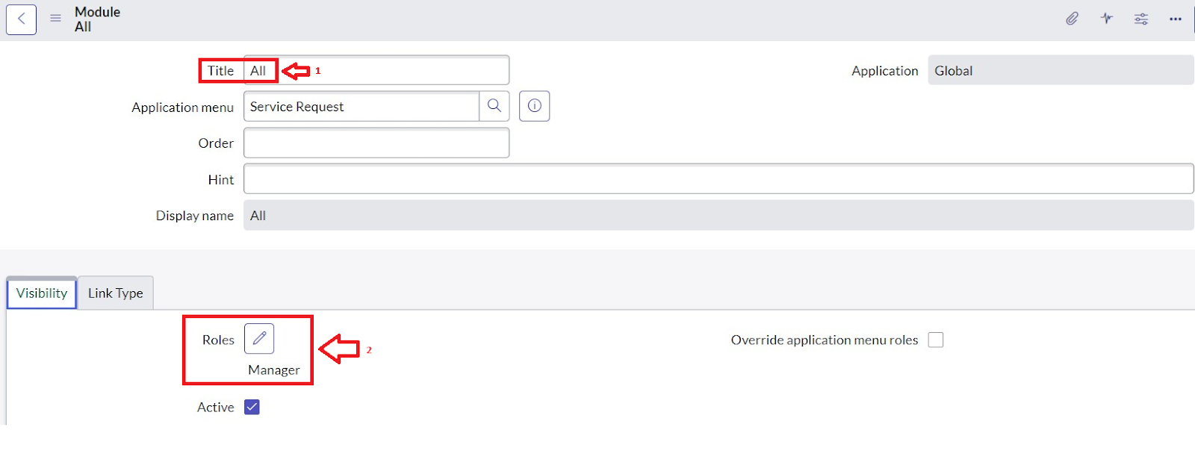

1. In Link Type, fill details as shown in figure.

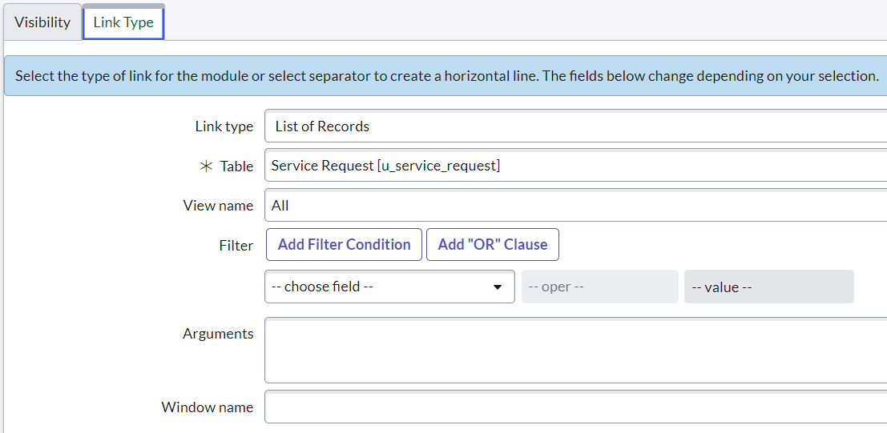

1. Click on Save.
2. After that the Modules would look like below.

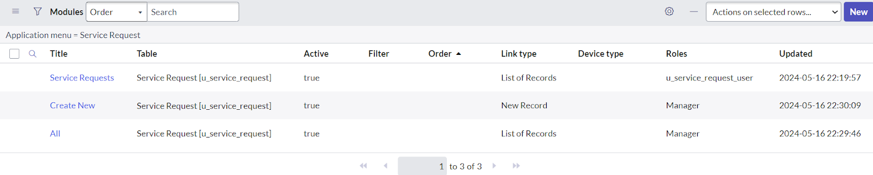

1. Hover over to the top and double click on the context menu and click on the Save.

**RESULT:**

1. Go to Profile and click on Impersonate user.

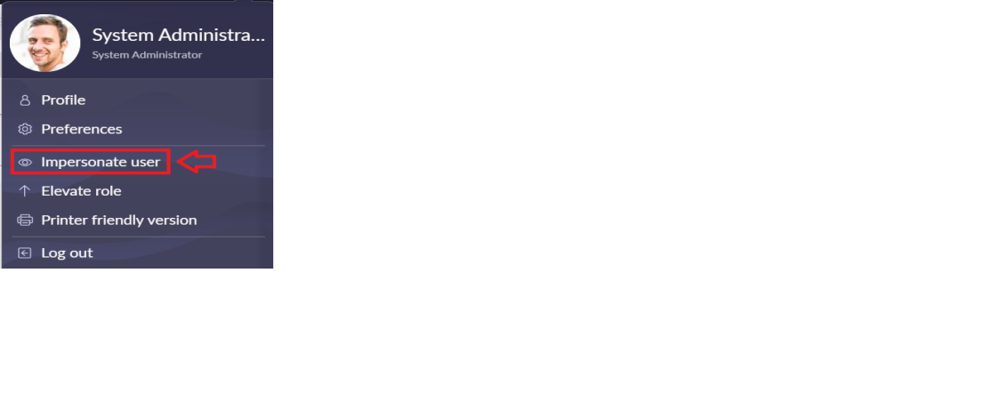

1. Select the user you have been created and click on Impersonate user.
2. Go to All >> search for Service Request
3. Then you can find The Application(Service Request) and Modules(Create New, All)

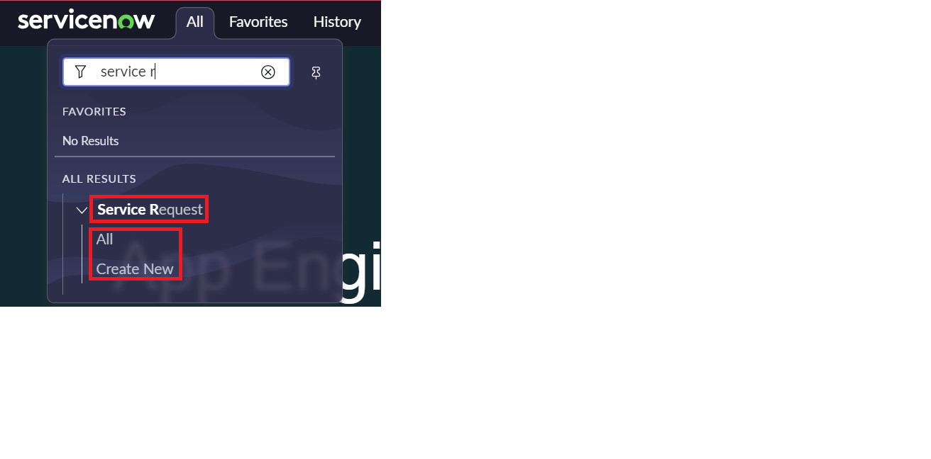

**OUTPUT:**

**Implementation Steps:**

1.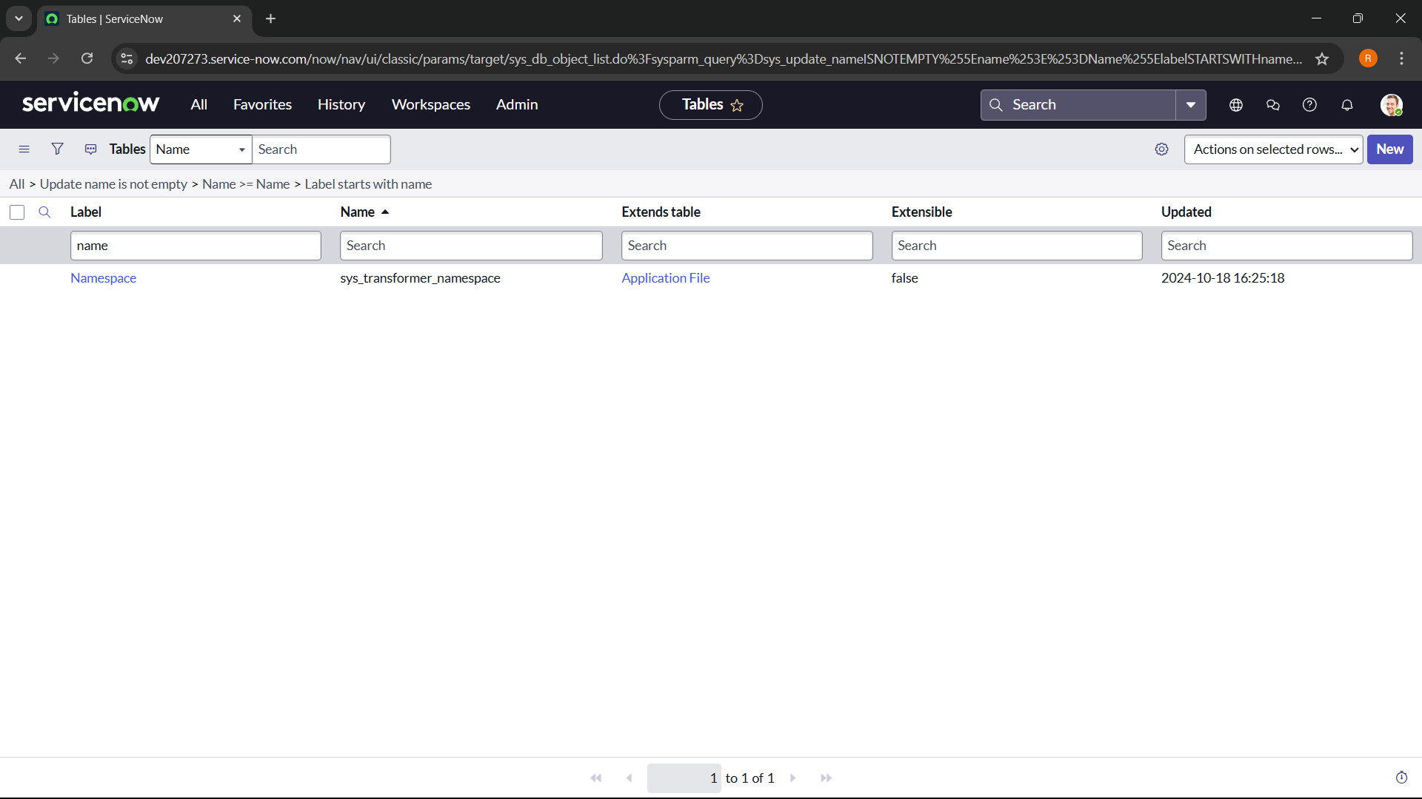

2.

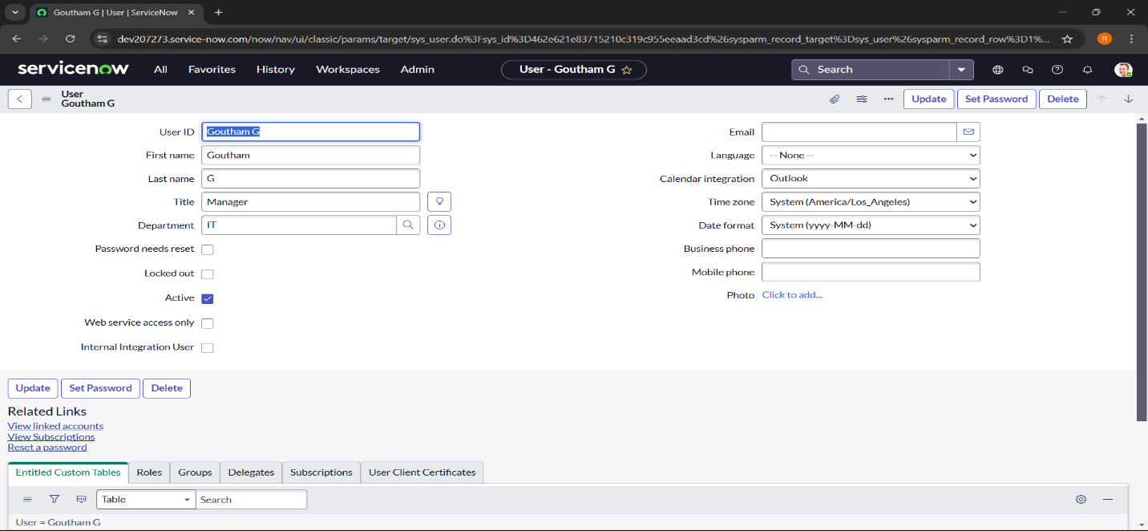

3.

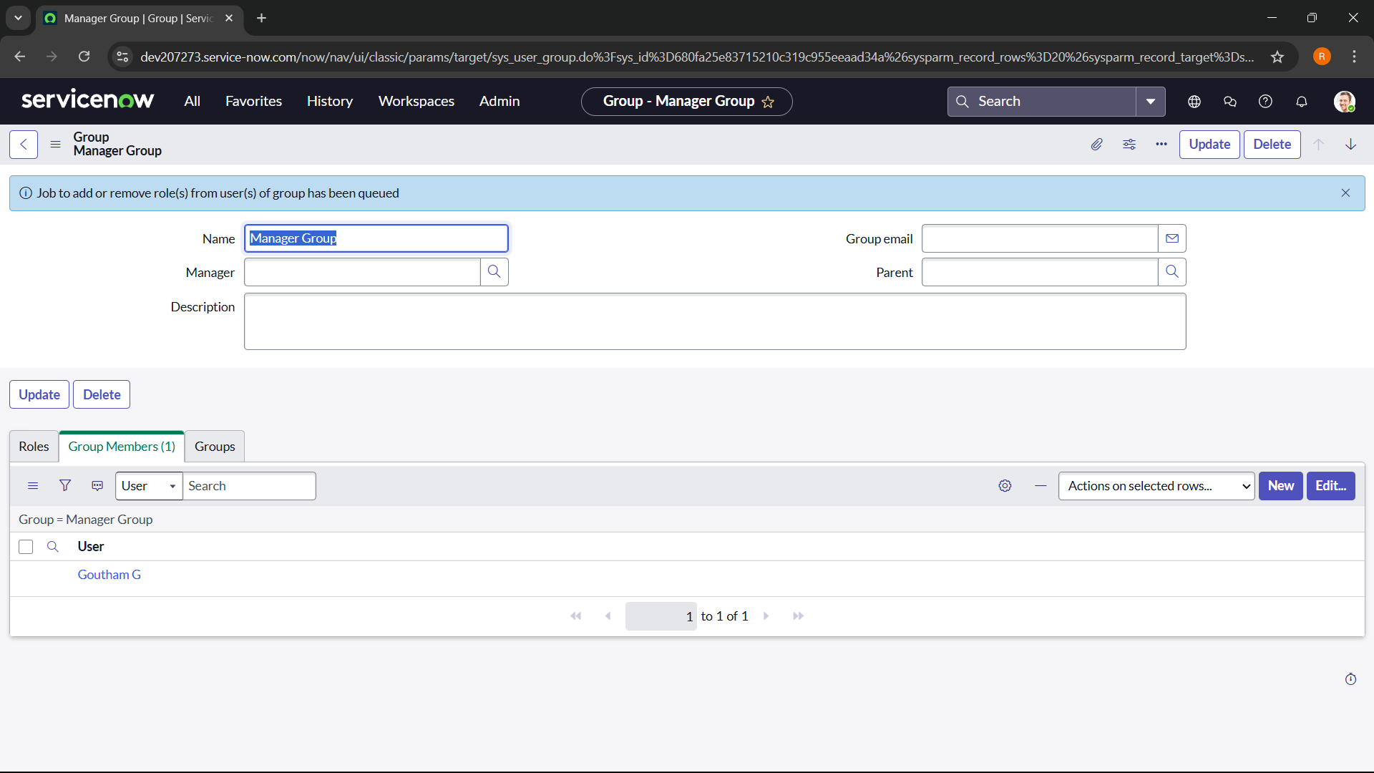

4.

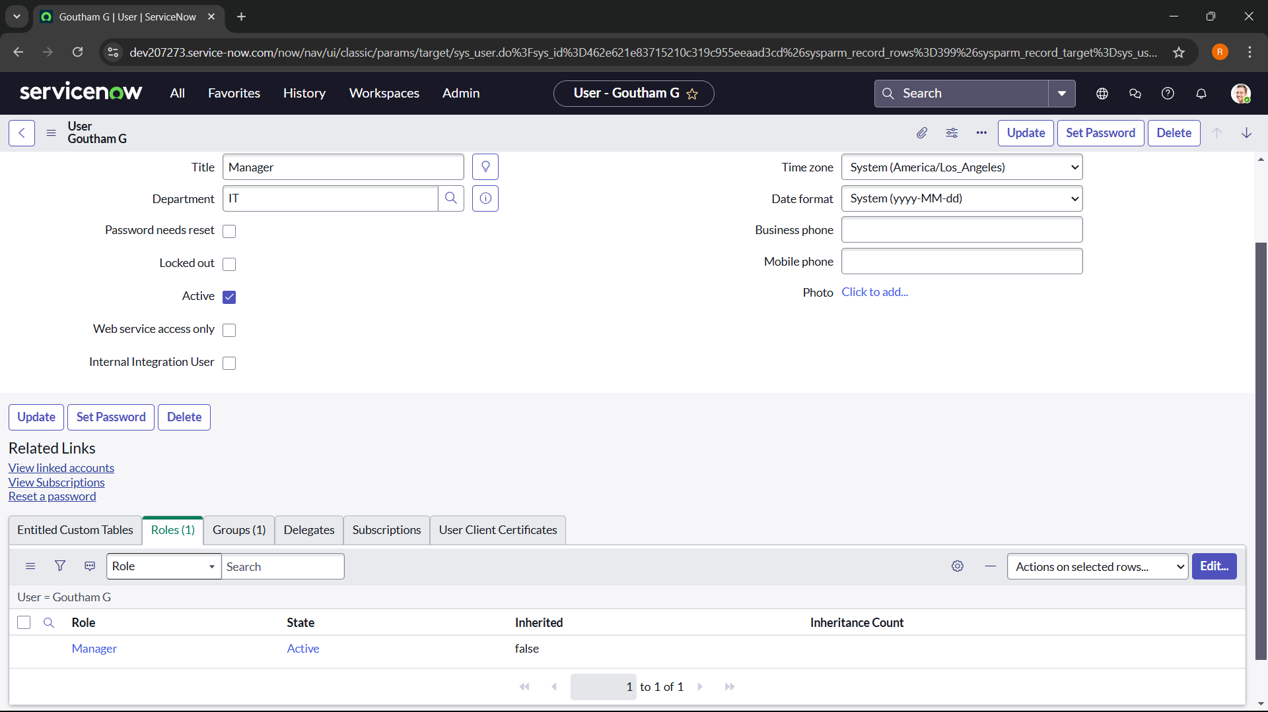

5.

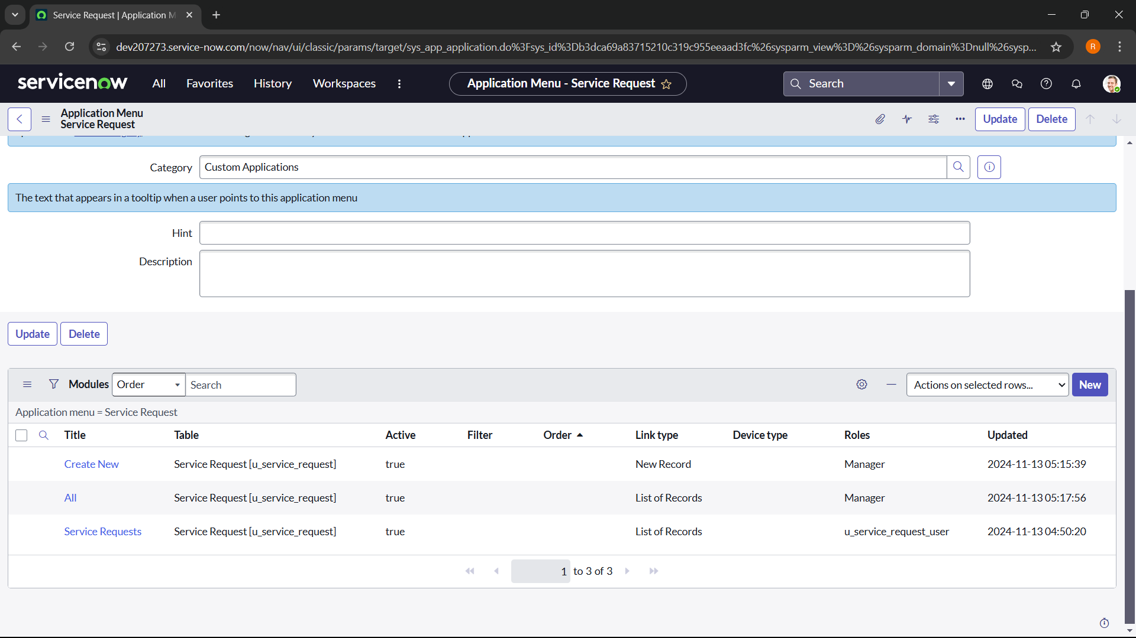

Final output:

